
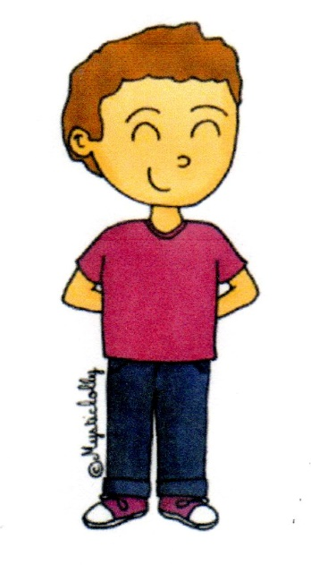
I
I
Je I majuscule
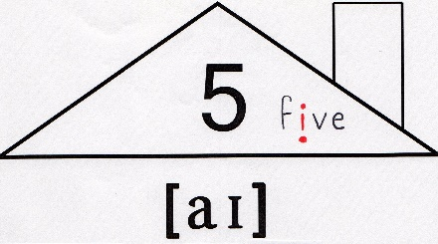
my : mon, ma
mes

I am Léo.
Can I open the window please ?
My name is Léo .
you
you

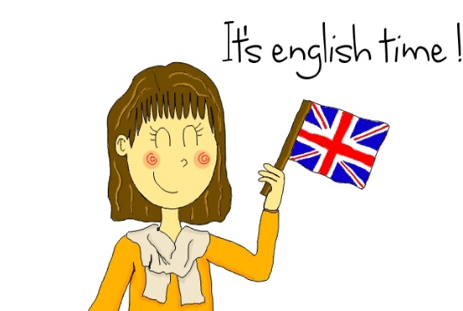
teacher

tu / vous

your : ton, ta / votre
tes / vos

Can you repeat please ? Can you open the window please ?
How are you ?

What ’s your name ?
