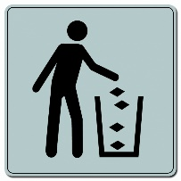
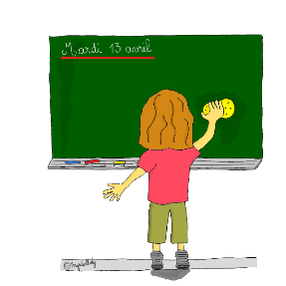
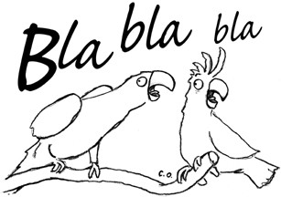

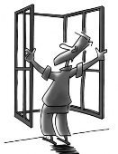
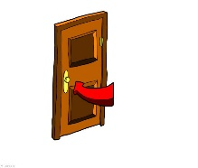


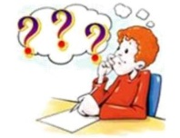

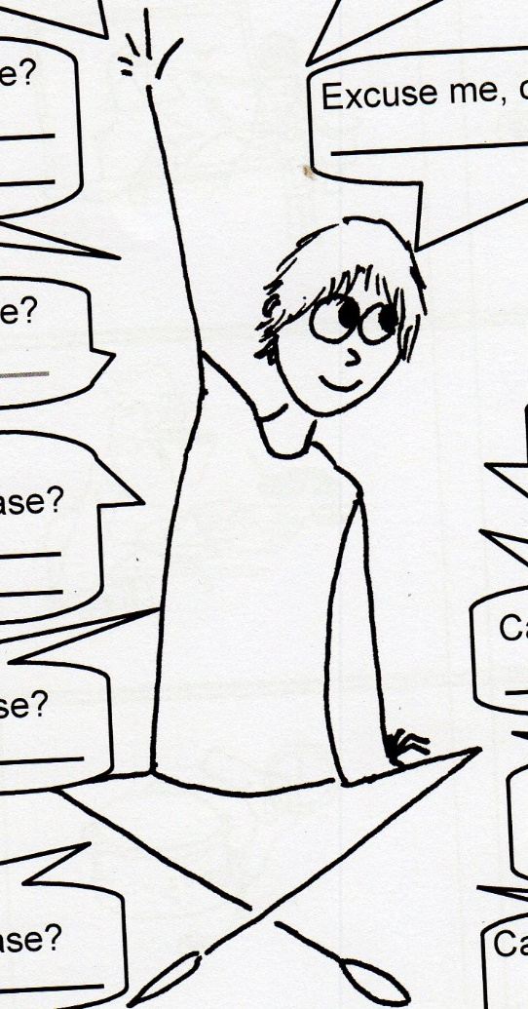
Can I put my chewing-gum
in the bin , please ?
Can I clean the board , please ?
Can you repeat, please ?
I don’t know .
Sorry, I ’m late .
What ’s the French for ?
I don’t remember .
I don’t understand .
What ’s the English for ?
Can I open the window , please ?
Can I close the door , please ?
Can I take a tissue , please ?

